**BCT Assignment 4**

**Neeti Kurulkar**

**Smart Contract for Student Data**

**Code:**

**// SPDX-License-Identifier: MIT**

**pragma solidity ^0.8.0;**

**contract StudentData {**

**// Structure for Student**

**struct Student {**

**uint id;**

**string name;**

**uint age;**

**string course;**

**}**

**// Array to store students**

**Student[] public students;**

**// Mapping to track uniqueness of student IDs**

**mapping(uint => bool) private studentExists;**

**// Add a student**

**function addStudent(uint _id, string memory _name, uint _age, string memory _course) public {**

**require(!studentExists[_id], "Student ID already exists.");**

**students.push(Student(_id, _name, _age, _course));**

**studentExists[_id] = true;**

**}**

**// Get student by array index**

**function getStudent(uint index) public view returns (uint, string memory, uint, string memory) {**

**require(index < students.length, "Invalid index.");**

**Student memory student = students[index];**

**return (student.id, student.name, student.age, student.course);**

**}**

**// Get total number of students**

**function getStudentCount() public view returns (uint) {**

**return students.length;**

**}**

**// Fallback function (when wrong data/call is sent)**

**fallback() external payable {**

**revert("Fallback called - function does not exist.");**

**}**

**// Receive function (when plain ETH is sent)**

**receive() external payable {**

**// ETH is accepted silently**

**}**

**}**

**Output:**

1. **Upload Code on Remix IDE**

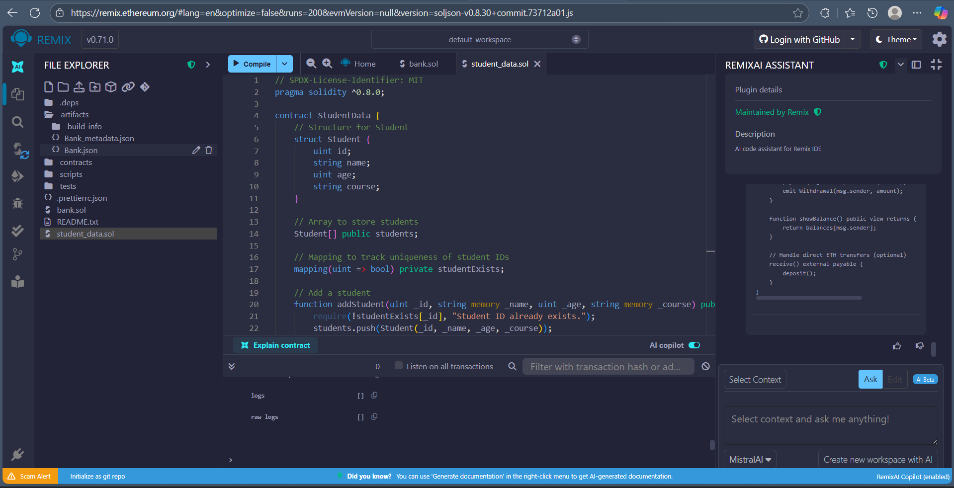

1. **Deploy Contract**

1. **Add Students**

1. **Get Student**

1. **Get Student Count**

1. **Observe Transactions**

